# Original code where errors can be seen.

To carry out the activity, it was decided to create a linear code structure, which is attached in the following images.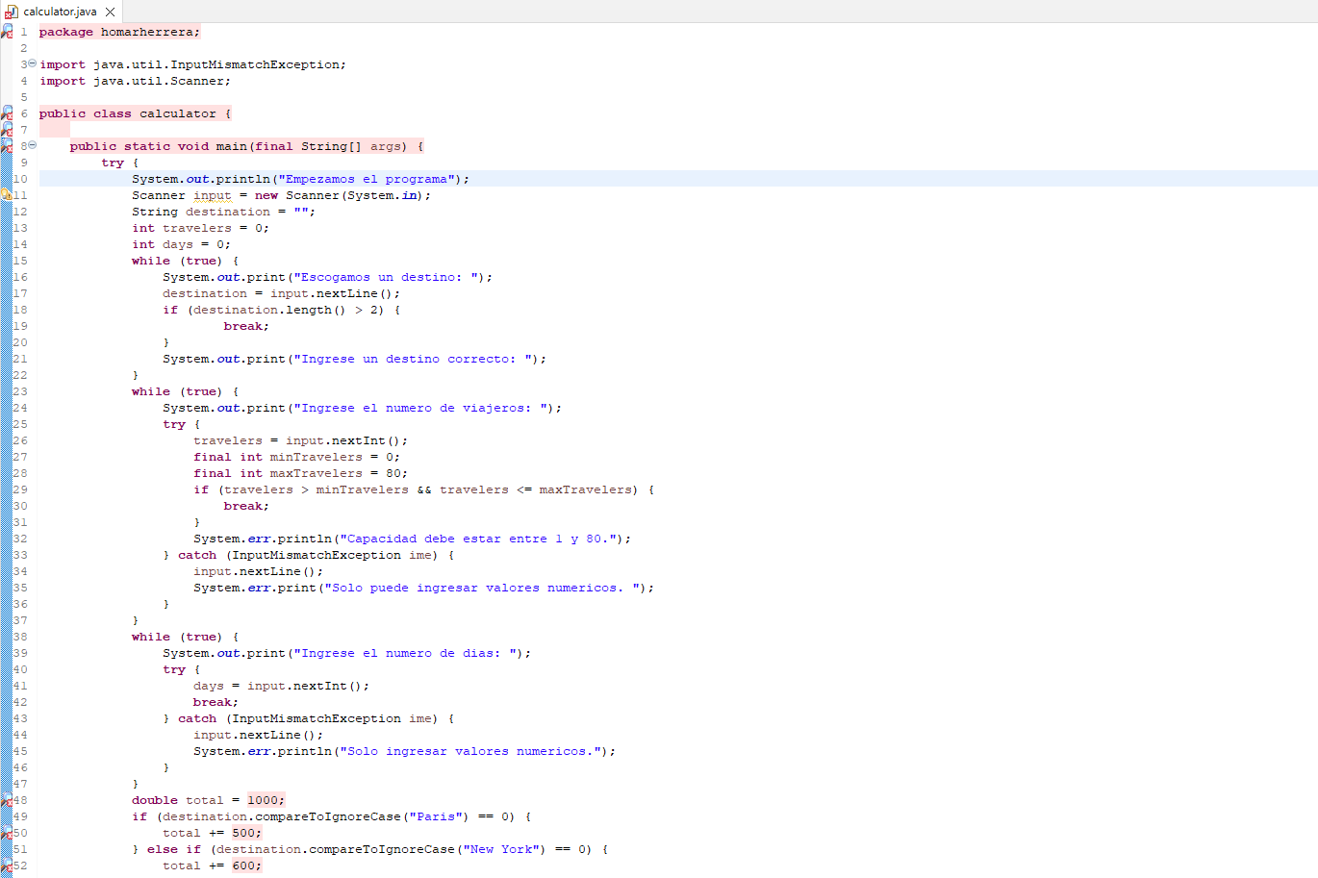

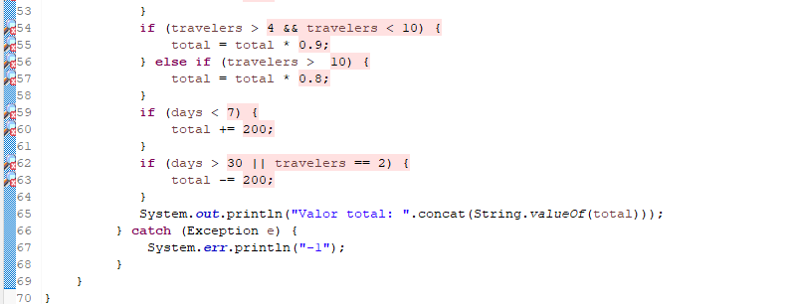

With the installation of the Checkstyle plugin, the following rules were configured:

• Indentation.

• Java methods.

• Whitespace After.

• Missing javadoc method.

• Avoid static imports.

After reviewing the errors and doing some research into their solution, they were eliminated, resulting in the result when running Maven.

For the competition, the SonarLint tool was used because the program was written in Java and mainly complexity, variable declaration and recurrence errors were obtained.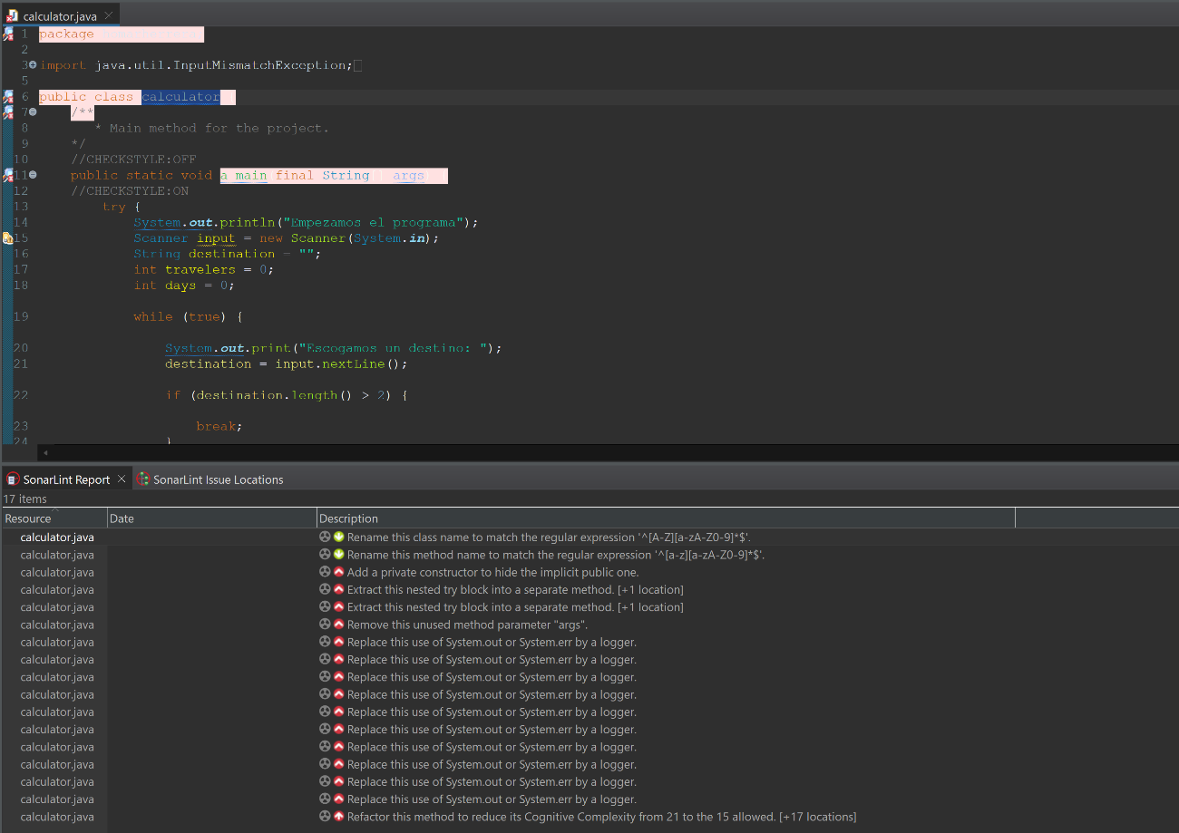

After correcting the errors and investigating how to eliminate the complexity, we proceeded to eliminate the rule of replacing with a logger, obtaining the following report from SonarLint.A screen shot of a computer
